Question-1

Pull an Image from docker hub and run it in docker playground

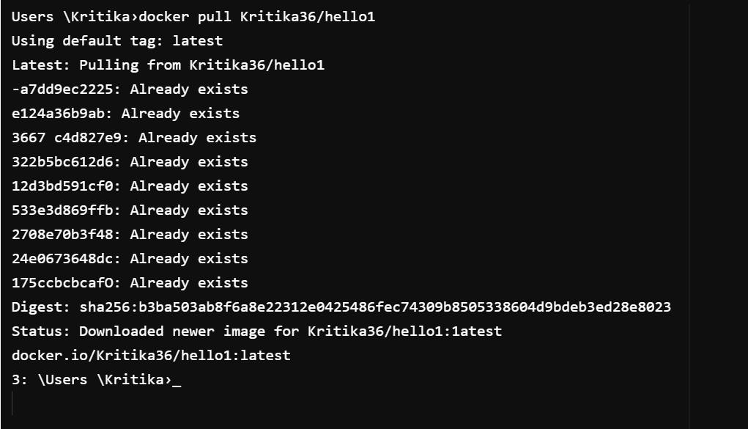

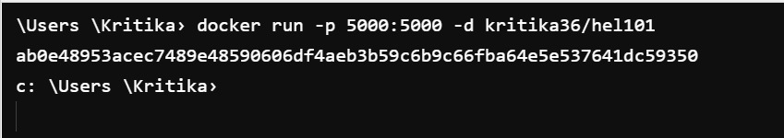

Question-2

Create a docker file for the jobportal application and deploy it in Docker desktop application.

# init a base image (Alpine is small Linux distro)  
FROM python:3.10.8-alpine  
# update pip to minimize dependency errors  
RUN pip install --upgrade pip  
# define the present working directory  
WORKDIR /hello1  
# copy the contents into the working dir  
ADD . /hello1  
# run pip to install the dependencies of the flask app  
RUN pip install -r requirements.txt  
# define the command to start the container  
CMD ["python","app.py"]

(venv) PS C:\Users\syed\PycharmProjects\hello1> docker image build -t hello1 .

Question -3

Create a IBM container registry and deploy helloworld app or jobportalapp

